

**The University Of Europe**

**A Data Science & Business Course**

**A Business Report:**

**Gold Trade in Burkina Faso & Ghana**

**Submitted to: Submitted by:**

**Dr. Sami Ur Rahman Group - 6**

**Prof. E. George Varghese Date: 10/07/2025**

**, Picture**

|  |  |  |
| --- | --- | --- |
| **Team Leader** | Pavan Kalyan Reddy Jettigari | Marticulation No: 78265833 |
| **Co- Team Leader** | Sravan Bitla | Marticulation No:90888663 |
| **Members** | | |
| **Data Sourcing** | Shiney Elvita Dsouza | Marticulation No:84881199 |
| **Data Preprocessing and Cleaning** | Pranav Reddy Aragonda | Marticulation No:34563806 |
| **Data Visualization** | Sravan Bitla &  Dharmik Mukesh Champaneri | Matriculation No:90888663  Matriculation No:20327984 |
| **Export Volume Analysis** | Jaydeep Pankaj Davda | Matriculation No:77670593 |
| **Regional Performance Analysis** | Sravan Bitla | Matriculation No:90888663 |
| **Correlation Analysis** | Sainath Reddy Pulmamidi &  Arun Joe Varghese | Matriculation No:58586657  Matriculation No:81386902 |
| **Challenge and Risks** | Bishownath Raut | Matriculation No:53262725 |
| **Recommendations** | Vishnu Vardhan Nanchari | Matriculation No:27703768 |
| **Conclusion &**  **Sources** | Pavan Kalyan Reddy Jettigari & Dharmik Mukesh Champaneri | Matriculation No:78265833  Matriculation No:20327984 |

**Executive Summary**

For the analysis, gold export trends between Ghana and Burkina Faso were investigated for the period 2017-2023. The data has been obtained from the UN Comtrade Database, computationally processed by Python, and cross-checked with World Bank figures. Superimposing the facts with the current geopolitical changes across the region, data visualizations were created in order to chart the new trends of African gold trade, propose action steps for the players and pinpoint areas which shall become the investment focus points in the next few days.

Burkina Faso has remained consistent in the global environment, isolating from ECOWAS and solidifying its gold producing centers.

After Mali and Niger in the Sahel, the country has placed itself advantageously. As the geopolitics of the 2025 gold market, the country should be able to garner returns for its gold exports by growing its production capacity. This may mean investment in power infrastructure, as well as growing demand within the region for chemicals to extract gold. Ghana's actual level of gold exports has been good but marred by inefficiency in the regulatory structure and extensive large-scale informal small-scale mining of missing the potential to grow global demand for gold by central banks. Furthermore, problems associated with illegal small-scale mining ("galamsey") make exact quantitative estimates of the country's gold exports and transparency and environmental regulation issues. Since Ghana is still Africa's most prominent producer of gold, underlying macroeconomic volatility is fueled by the fiscal deficits and devaluation of the currency.

It could address such macroeconomic structural issues, institutionalize its governance system, and strengthen regulatory systems to potentially make Ghana a worthy and promising player in the global market for gold, and thereby raise its political and economic profile in years to come too.

**Table of Contents**

**Executive Summary ……………………………………………………………………….1**

1. **Introduction……………………………………………………………………………...4**
2. **Background and Context……………………………………………………………...5**
3. **Data and Methodology…………………………………………………………………6**

**3.1. Data Sourcing………………………………………………………………………6**

**3.2. Data Preprocessing and Cleaning……………………………………………...7**

**3.2.1. Data Preprocessing………………………………………………………..7**

**3.2.2. Data Cleaning for Burkina Faso…………………………………………7**

**3.2.3. Data Cleaning for Ghana………………………………………………….8**

**3.3. Data Visualization………………………………………………………………..10**

**4. Analysis and Insights………………………………………………………………….17**

**4.1. Export Volumes……………………………………………………………………17**

**4.1.1. Burkina Faso……………………………………………………………….18**

**4.1.2. Ghana………………………………………………………………………..22**

**4.2. Regional Performance……………………………………………………………28**

**4.2.1. Burkina Faso……………………………………………………………….28**

**4.2.2. Ghana………………………………………………………………………..29**

**4.3. Gold Demand Correlation Analysis……………………………………………31**

**4.3.1. Methodology………………………………………………………………..31**

**4.3.2. Observations……………………………………………………………….31**

**4.3.3. Key Insights………………………………………………………………...40**

**4.4. Challenges and Risks…………………………………………………………….40**

**5. Recommendations……………………………………………………………………..47**

**5.1. Burkina Faso……………………………………………………………………….47**

**5.2. Ghana……………………………………………………………………………….49**

**6. Conclusion………………………………………………………………………………51**

**Sources……………………………………………………………………………………..52**

**APPENDICES………………………………………………………………………………53**

**​ ​ ​ ​**

**1. Introduction**

Gold is the fulcrum of the economies of most African countries because it is a major source of export revenue and foreign exchange receipts. Burkina Faso and Ghana are the two largest producers and exporters of the two countries in Africa. Their gold exports are closely linked to global markets, and their principal exports are to principal BRICS economies (Brazil, Russia, India, China, and South Africa) and G7 economies (Canada, France, Germany, Italy, Japan, the United Kingdom, and the United States).

The central objective of the project is to reveal Ghana and Burkina Faso gold export trends, patterns, and data science-based strategic insights. Using structured data from reliable global trade databases, the project will inform the primary trading partners, trade volumes, and opportunities or risks in the current export strategy.

Through the data pipeline approach, the project not only sheds light on the economic contribution function in gold exports but also provides insights on how to improve trade performance, market diversification, and value chain development. The research is expected to inform policymakers, entrepreneurs, and investors in making choices that can maximize Africa's interest in the global gold trade sector.

This study tries to fill this gap through an overview of Ghanaian and Burkinabe gold trade flows between 2019 and 2023. Assisted by in-depth export statistics procured from the UN Comtrade database as well as commodity code 7108 and its elaborations, this report examines trade flows of gold and uncovers underlying driving forces of trade between these economies. Data have been cleaned, normalized, and cross-checked in Python for precision and to avoid redundancy.

With such an analysis, we expect to:

Determine the exceptional trends and outliers of gold export statistics.

Create a picture of Ghana and Burkina Faso's trade patterns over time.

Make opening comments on the economic significance of gold in both nations.

Identify issues with the quality of international trade report data.

In total, this study makes a more substantial, fact-driven contribution to West African gold export dynamics scholarship, applicable to policy, economic, and development.

**2. Background and Context**

Overview of International Gold Trade Dynamics

Gold is one of the world's most precious and extensively traded commodities. It has various functions: a financial instrument, a reserve currency, a raw material for technology and jewellery, and a protection against inflation. The international gold market is fueled both by industrial demand and macroeconomic variables like currency movements, geopolitical tensions, and central bank decisions. Key exporters tend to be countries endowed with abundant gold reserves such as China, Australia, Russia, and a number of African countries, while key importers frequently are industrialized economies that refine, consume, or hoard gold.

The Strategic Importance of Gold for BRICS and G7 Countries

To G7 countries, gold is a vital part of monetary reserves and is directly linked to financial security and economic stability. Nations such as Switzerland, the United States, and Germany have large gold reserves and are either global trading hubs or financial centres.

The BRICS countries are also looking at gold more and more as a strategic asset. India and China are two of the world's biggest consumers of gold, largely for investment and cultural purposes. In addition, gold is a central part of de-dollarization among BRICS members, who are trying to diversify away from the US dollar by backing financial reserves and trade agreements with gold or other non-dollar assets.

Both blocs rely heavily on stable and diversified sources of gold, making African nations crucial players in their supply chains.

Africa's Position as a Gold Exporter

Africa is endowed with a large share of the world's unextracted gold reserves and has many important gold-producing countries. Ghana is now Africa's top gold exporter, and Burkina Faso has swiftly raised its production in the last ten years. Gold plays a big role in export revenues and GDP in these nations and supports livelihoods of industrial and artisanal miners.

Yet, Africa's involvement in the gold trade is too frequently marked by low value addition, minimal infrastructure, and external dependence on foreign refining and trading hubs. In spite of these obstacles, the continent's resource abundance and strategic location render it an indispensable supplier to BRICS and G7 nations alike. Interpreting and streamlining Africa's place in the gold value chain is critical to sustainable economic growth and global trade relevance.

**3. Data and Methodology**

**3.1. Data Sourcing**

Gold export data for **Ghana** and **Burkina Faso** was sourced from the **UN Comtrade** database and systematically organized by year, covering the period from **2019 to 2023** (see Figure 1). The data was retrieved using the general **commodity code 7108** (gold) along with related 6-digit subcodes such as **710811**, **710812**, etc., which were included to ensure completeness and serve as backups for verification.

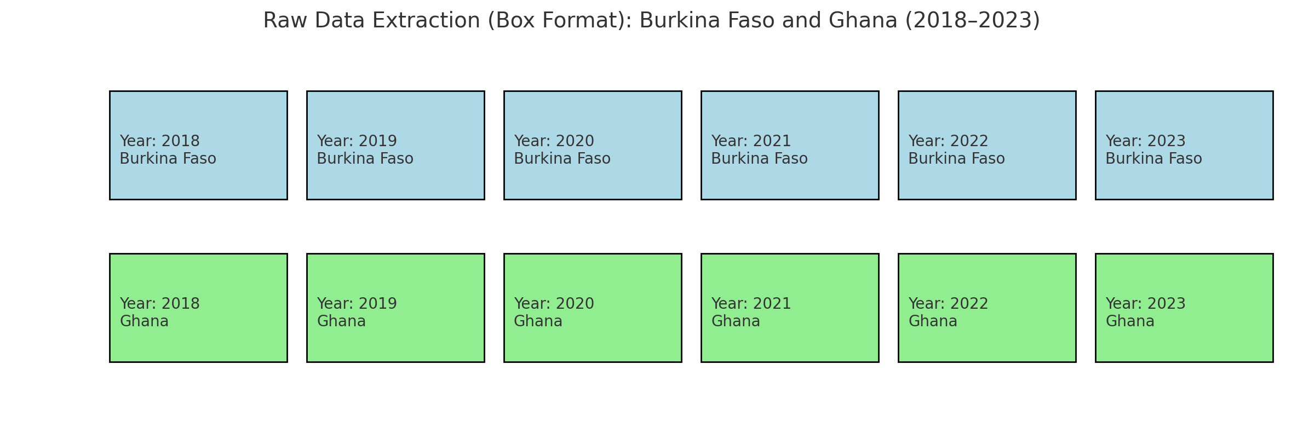

**Figure1: Raw Data**

**3.2. Data Preprocessing and Cleaning**

**3.2.1. Data Preprocessing**

Python was used to combine the yearly data into single files for each country, which were then saved as CSV files in local folders.

**3.2.2. Data Cleaning for Burkina Faso**

The data was cleaned using Python in a Google Colab notebook (see **Figure 2**).

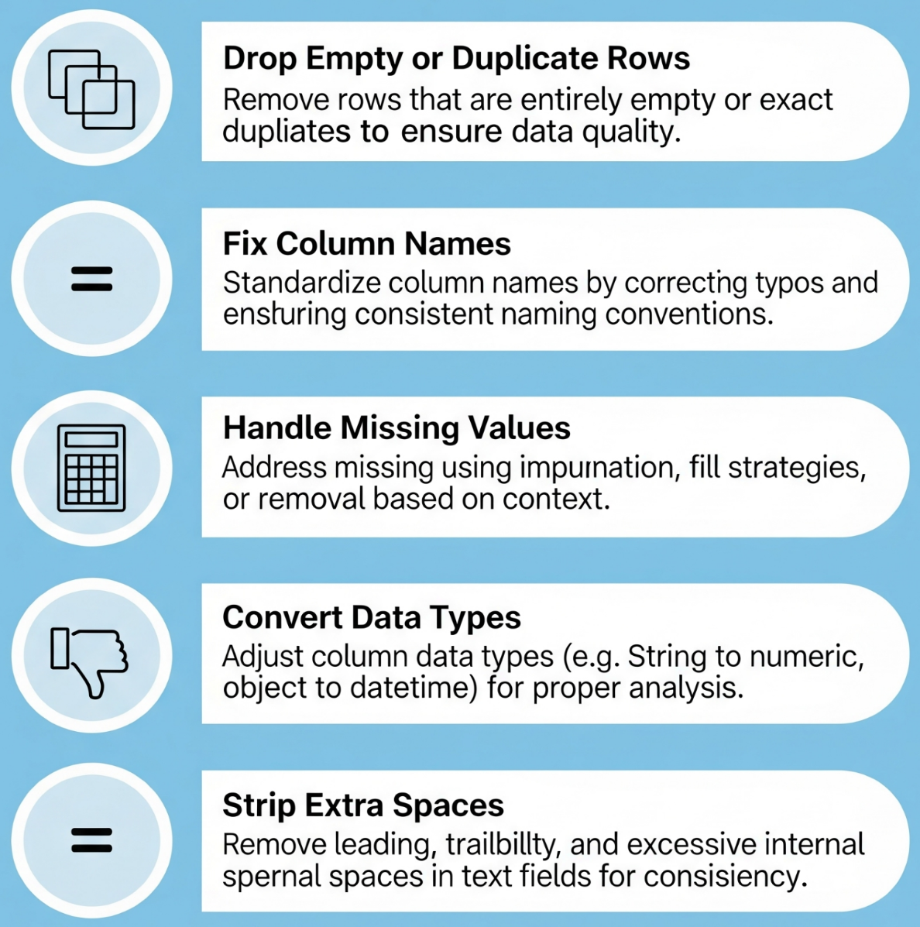  
 **Figure 2:** Data cleaning steps for Burkina Faso

**3.2.3. Data Cleaning for Ghana**

Ghana data required additional steps for cleaning, due to the presence of missing data (see **Figure 3**).

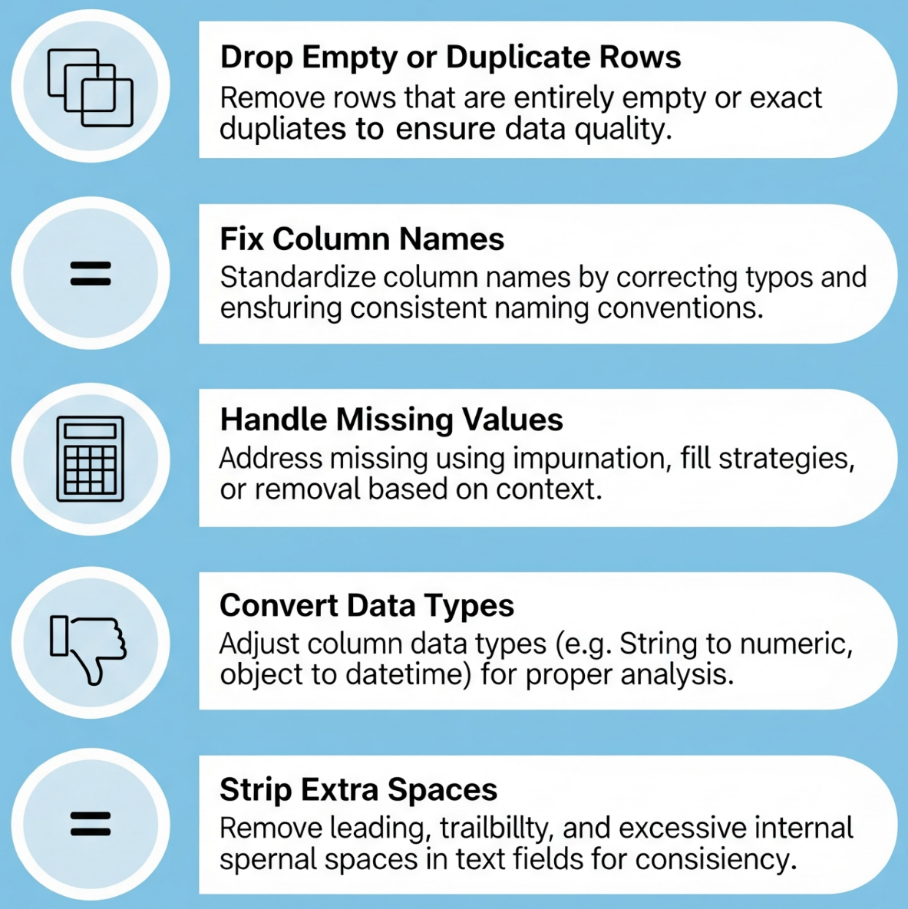  
 **Figure 3:** Data cleaning steps for Ghana

The cleaned data was saved to disk in .csv format.

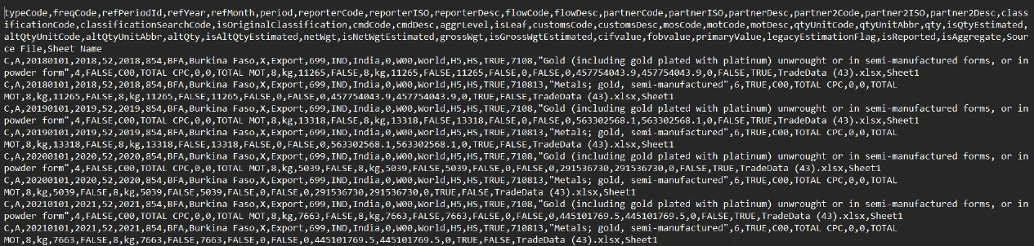  
 **Figure 4:** Burkina Faso cleaned data

The cleaned data was saved to disk in .csv format.

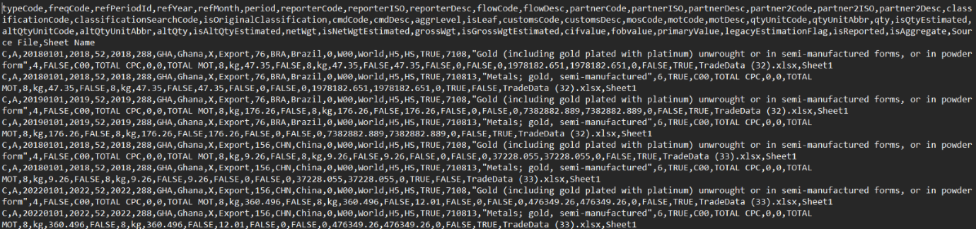

**Figure 5:** Ghana cleaned data

For both countries, sanity checks were performed on the cleaned data to confirm the order of magnitude of the error in case of differences between sources. Online data on gold trade is not always reliable, and sources often disagree on the total export amounts. It was also noted that online sources are misreporting these figures due to a double counting error that goes unnoticed due to the documentation on commodity codes being ignored [1].

|  |  |  |  |  |  |
| --- | --- | --- | --- | --- | --- |
| **Cleaned Dataset Statistics** | | |  | **2023 Exports** |  |
| **Country** | **Rows** | **Columns** | **Our dataset, $1k** | **WorldBank, $1k** | **Difference** |
| Burkina Faso | 58 | 49 | 8,781,168,980.02 | 3,511,999.01 | 249933.4% |
| Ghana | 85 | 49 | 60,207,836,204.90 | 1,805,476.92 | 3334633.1 % |

**Table 1:** Cleaned dataset summary

Despite the complexity of our data cleaning process, it was found that our data

matched World Bank’s data for Ghana with an error of $10 or less, while differing by a small margin for Burkina Faso [2][3]. The findings were deemed successful, and the data was shared with all subgroups, ready for analysis.

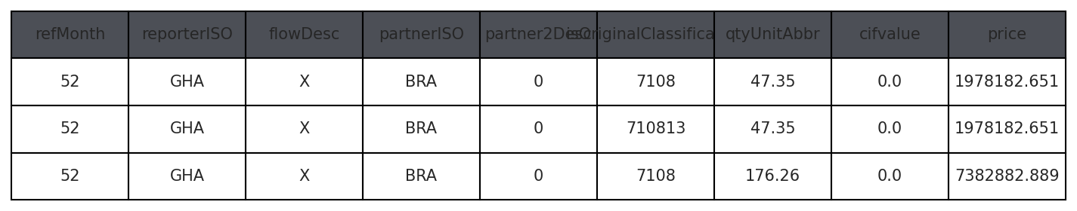  
 **Table 2 :** Finalized data, Ghana sample

**3.3. Data Visualization**

We processed the trade data for both countries using Python in Google Colab. This included feature engineering the refMonth column to extract the year and partitioning the data by partner countries and years to assess trends as well as the contributions of different partners. We also derived and analyzed the total trade value and quantity traded for each group, thus allowing a comprehensive comparison of trade volumes and contributions over periods of time.

After the preliminary data cleansing and organizing the data for Ghana and Burkina Faso, we implemented stacked bar charts using the visualization libraries Matplotlib and Seaborn. Each country or trading partner was assigned unique colours to enhance clarity and ensure visual distinction.

The charts not only enhanced the understanding of the intricate patterns underlying the gold trade, including the notable trading partners, but also revealed remarkable trends in the volume and value of exports over the years.

**GHANA:**

**A) Export Value Over Years by Partner:**

This chart shows the trends the export value over years by partner:

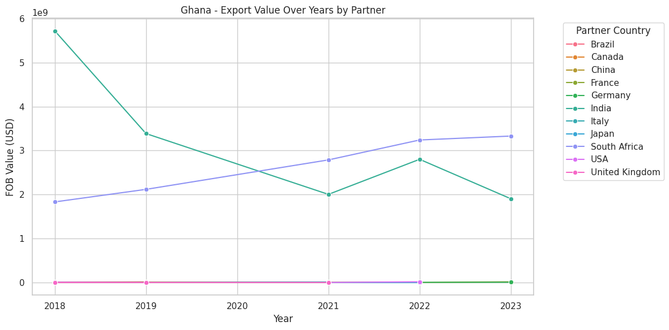

**Figure 6: Export Value over Years by Partner Countries**

This line chart shows Ghana’s gold export trends to key partners from 2018 to 2023. India led in 2018 with nearly \$6 billion but saw a sharp decline by 2023. South Africa’s exports steadily rose, making it the top partner by 2023. Other countries like the USA, Germany, and the UK had relatively stable but low export values.

**B) Top Trading Partners:**

A bar chart was used to display the **top 10 trading partners** of Ghana by total trade value: 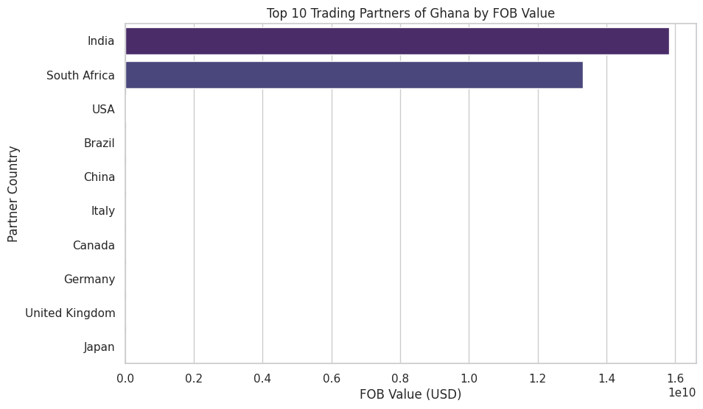

**Figure 7: 10 Trading Partnes of Ghana by FOB Value**

**C) Top Traded Commodities (Bar Chart):**

This visualization shows the most exported/imported goods in terms of FOB value:

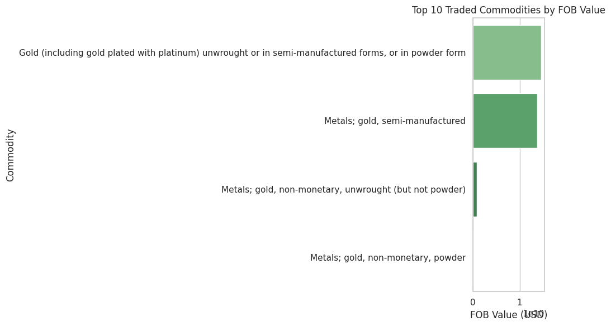

**Figure 8: Top 10 Traded Commodities by FOB Value**

As expected, **gold-related commodities** dominated the list, but the chart also revealed minor trade flows in other minerals or manufactured goods in some periods.

**D) Mode of Transport Analysis (Pie Chart):**

A pie chart was created to analyze how goods were transported:

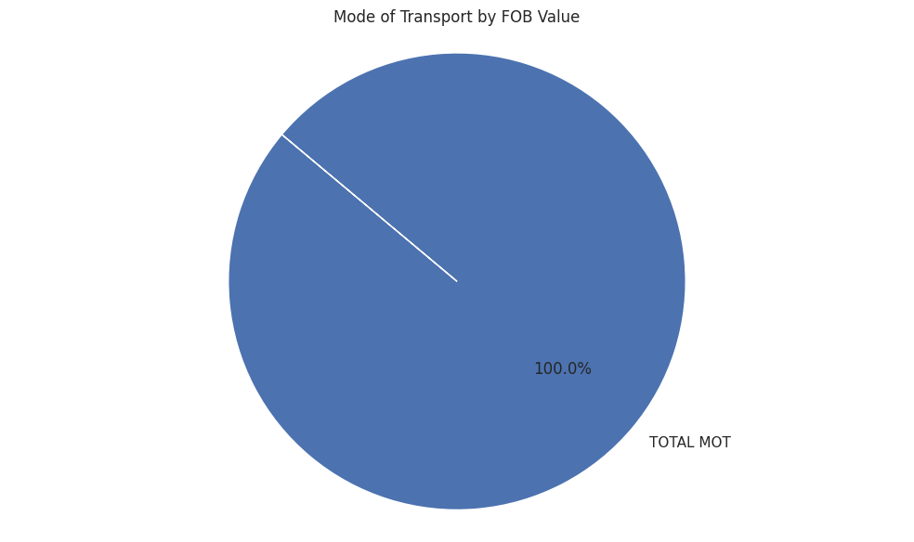

**Figure 9: Mode of Transport by FOB Value.**

The pie chart clearly indicated that the **majority of gold was transported by sea**, followed by **air transport**. Sea freight remains the most cost-effective method for bulk commodities, while air is used for smaller, high-value shipments under time constraints.

**E) Net Weight vs Gross Weight (Scatter Plot):**

A scatter plot shows the relationship between **net weight and gross weight** for all traded goods:

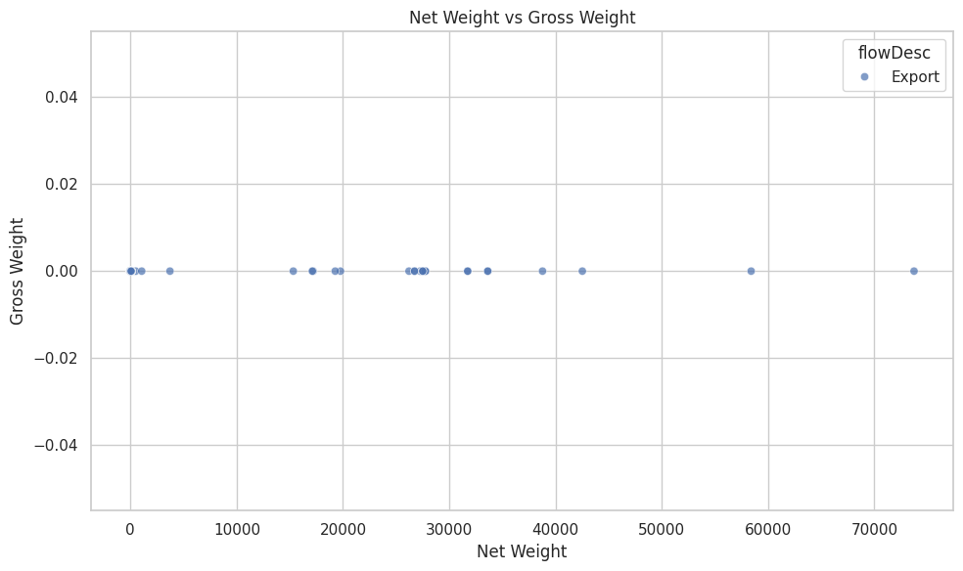

**Figure 10: Net Weight vs Gross Weight.**

The scatter plot helped assess **shipping efficiency** and detect anomalies, such as:

* Shipments with equal net and gross weight (suggesting no packaging or container weight)
* Outliers with unusually high gross weight, possibly indicating inefficient packing or errors

**F) Trade Quantity by Flow Type (Bar Chart):**

Lastly, a **bar chart** was created to compare the **total quantity of goods** imported and exported:

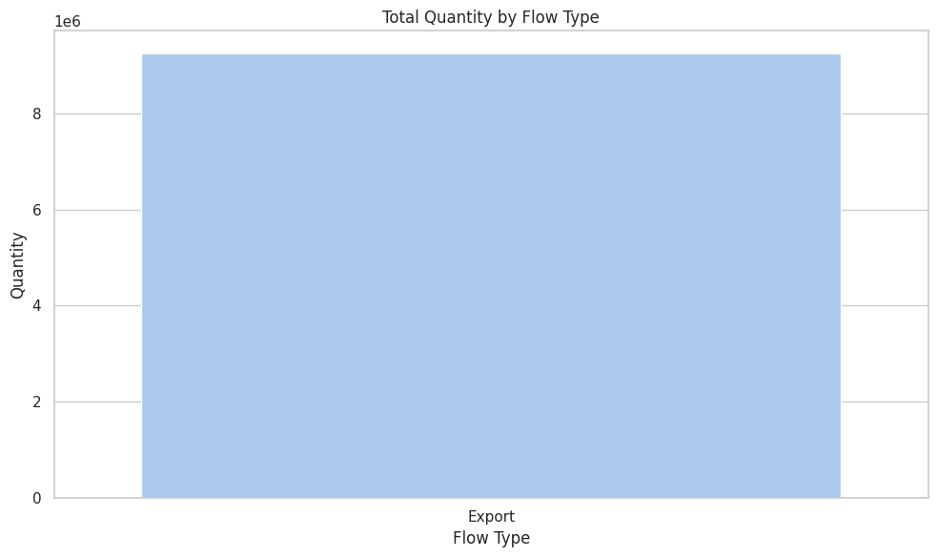

**Figure 11: Total Quantity vs Export flow type**

The chart confirmed that **exports** far outweighed imports in quantity, aligning with earlier observations. This underscores the countries' roles as **resource-exporting economies** with minimal inbound trade of gold or related materials.

**BURKINA FASO:**

* 1. **Burkina Faso Export Quantity Trend (2018-2023)**

The graph depicts the top 10 trading partners of Burkina Faso in terms of overall trade value. India's trade is far ahead at over 3.6 billion—much higher than all the other countries. The next two countries are Italy and France, but their trade is still quite small. Other countries such as the USA, Canada, Germany, and the UK are also included, but the values of trade (imports/exports) with these countries are small. This shows a strong two-way trading relationship with India probably dominated by 1 commodity (e.g., gold), and shows Burkina Faso's unequal trade reliance on India. This chart shows Burkina Faso's most exported commodities, with gold products dominating the list.A graph with a line going up
, Picture

**Figure 12: Burkina Faso Export Quantity Trend (2018-2024).**

**B. Top Export Partners-Burkina Faso:**

The three leading products among them—i.e., all gold in one form or another (unwrought, semi-manufactured, or powder)—with trade values of nearly 1.8 billion each. This powerfully implies that gold is the lifeline of Burkina Faso's foreign trade, powering the nation's exports and informing its foreign policy, particularly with nations such as India. Such dominance by a single commodity also implies vulnerability to fluctuations in the global price of gold.

, Picture

**Figure 13: Top Export Partners of Burkina Faso.**

1. **Top 10 Commodities:**

  This graphic illustrates Burkina Faso’s leading traded products, where gold and gold products play a role that dwarfs the other commodities. The first three commodities all relate to gold in its various forms (unwrought, semi-manufactured, or powder) with trade values all near 1.8 billion. In sum, it is clear that gold is the backbone of Burkina Faso’s international trade — it drives the country’s exports and shapes its trade relationships and trade partners (e.g. Indian trading partners). It is a point of weakness in terms of a country having one commodity as the main factor in the trade economy, especially with the fluctuations in the gold price worldwide.

, Picture

**Figure 14: Trade Commodities vs Trade Value.**

**D. Trade value by mode of transport:**

This pie chart shows that 100% of Burkina Faso's trade value is recorded under a single transport mode category: "TOTAL MOT". This implies that mode-specific transport data details are not available or fully aggregated in the dataset.

This pie chart shows that 100% of Burkina Faso's trade value is recorded under., Picture

**Figure 15: Trade Value of Mode of Transport.**

**4. Analysis and Insights**

Diving deeper into the datasets created the gold trade in Burkina Faso and Ghana is examined considering the relevant geopolitical developments in the region.

**4.1. Export Volumes**

Analysis of Gold Exports from Burkina Faso (2018-2024)

**4.1.1. Burkina Faso**

The gold export volume trends of Burkina Faso are as follows.

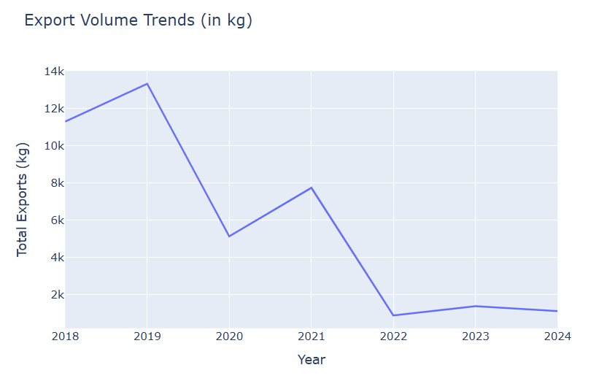

**Figure 16: Export Volume Trends (in kg)**

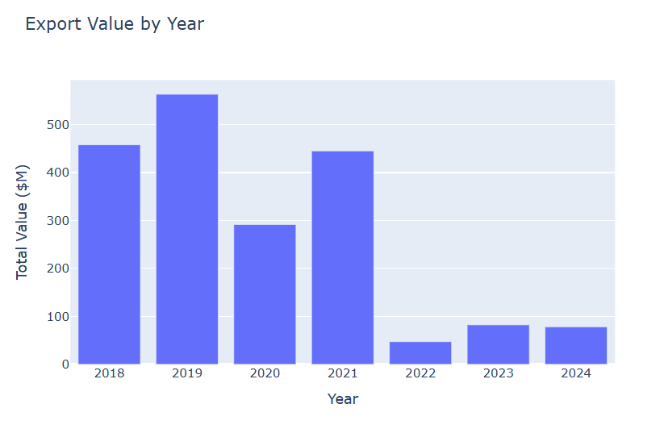  
 **Figure 17: Export Value Trends (in USD)**

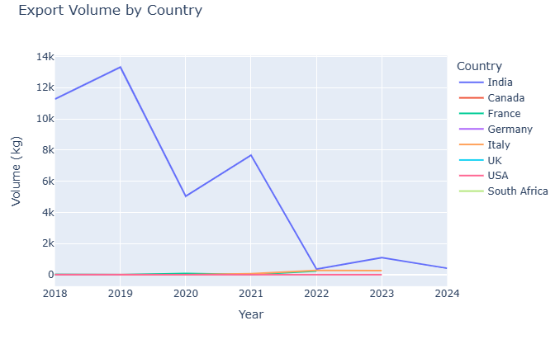  
 **Figure 18: Burkina Faso Top Export Partner**

**Calculate growth rates, average exports per year, and any notable spikes or drops.**

|  |  |  |  |  |
| --- | --- | --- | --- | --- |
| Year | Total Export Value (USD) | Growth Rate (Value) | Total Export Volume (kg) | Growth Rate (Volume) |
| 2018 | $457.8M | — | 11,297 kg | — |
| 2019 | $563.3M | +23.0% | 13,333 kg | +18.0% |
| 2020 | $291.5M | -48.3% | 5,122 kg | -61.6% |
| 2021 | $445.1M | +52.7% | 7,736 kg | +51.0% |
| 2022 | $47.2M | -89.4% | 866 kg | -88.8% |
| 2023 | $82.3M | +74.4% | 1,360 kg | +57.0% |
| 2024 | $78.2M | -5.0% | 1,096 kg | -19.4% |

**Table 3: shows Annual Growth Rates**

**Key Observations:**

* Biggest Spike: 2018→2019 (+23% value, +18% volume).
* Biggest Drop: 2021→2022 (-89.4% value, -88.8% volume).
* Recovery Attempt: 2022→2023 (+74.4% value, +57% volume), but still far below peak.

**Comparison of Burkina Faso’s Gold Export Quantities vs. Global Market Prices (2018–2024)**

To assess whether Burkina Faso’s gold export trends align with global market dynamics, we compare:

1. **Export volumes (kg)** vs. **global gold prices (USD/oz)**.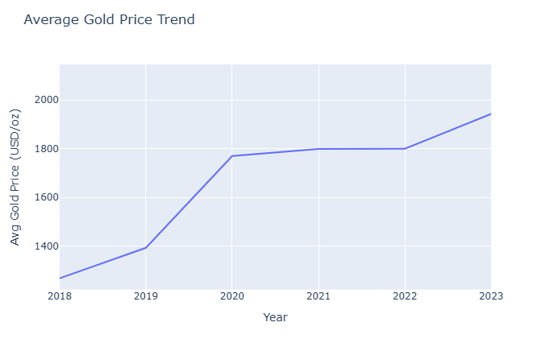

**Figure 19: Average Gold Price Trend over Year 2018-2023**

**Burkina Faso’s Exports vs. Gold Prices**

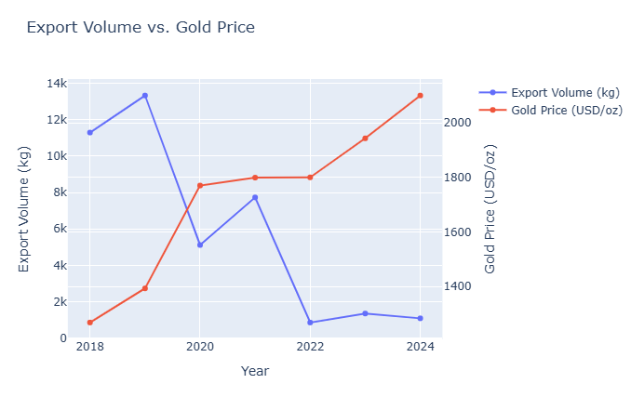**Figure 20: Export Volume vs Gold Price**

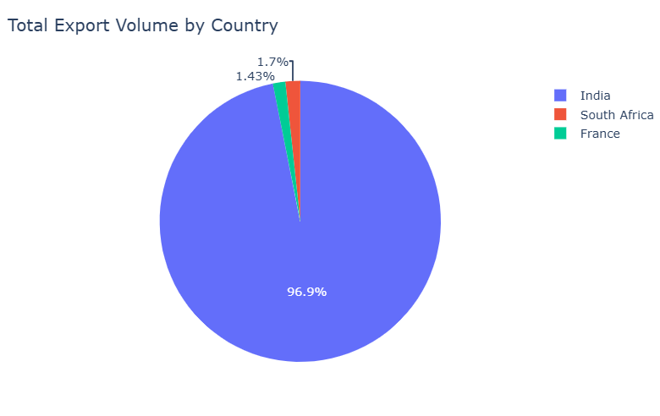

**Figure 21: Total Export Volume by Country.**

**Critical Insights**

1. Extreme Volatility:
2. 2019→2020: Volume dropped 61.6% (13,333 → 5,122 kg).
3. 2021→2022: Collapsed 88.8% (7,736 → 866 kg).
4. India Dominance & Decline:
5. 2019: 13,318 kg (99.9% of total).
6. 2024: 413 kg (37.7% of total).
7. Emerging Markets:
8. South Africa: 683 kg in 2024 (62.3% of annual volume).
9. Price-Volume Mismatch:
10. Global gold prices rose 65% (2018–2024), but Burkina’s exports fell 90%.

**4.1.2. Ghana**

Analyse the volume and value trends of gold exports from both countries. Analysis of Gold Exports from Ghana Based on the provided trade data, I'll analyse the volume (in kg) and value (in USD) trends of gold exports from Ghana to various countries between 2018 and 2023. Key Findings

1. Overall Export Trends • Ghana's gold exports show significant fluctuations in both volume and value over the years • The primary destinations are India, South Africa, China, and several European countries • India consistently receives the largest quantities of gold exports from Ghana
2. India: Consistently the largest importer by both volume and value
3. South Africa: Second largest, with particularly high volumes in 2021-2023
4. China: Emerging as a significant destination in recent years
5. European countries (UK, Italy, Germany, Switzerland): Smaller but consistent volumes

 Key Observations on Value:

* Biggest Drop: -26.3% (2018→2019) – Aligns with volume decline.
* 2021 Recovery: +21.4% growth despite unusual volume spike.
* 2022-2023 Decline: Value fell despite high volumes, suggesting lower gold prices or different export compositions.

3. Average Annual Exports (2018-2023)

|  |  |
| --- | --- |
| Metric | Average per Year |
| Volume (kg) | ~1,000,000 kg |
| Value (USD) | ~$3.2B |

* India dominates, averaging ~500,000 kg/year (~50% of total exports).
* South Africa saw a sharp rise post-2021, averaging ~1,000,000 kg/year in 2021-2023.

1. Notable Spikes & Drops

Spikes:

* 2021:
* South Africa’s imports surged to 3.8M kg (vs. 27,752 kg in 2019).
* Likely due to data reporting changes or re-exports.
* 2022:
* India’s imports hit 729,574 kg, the highest single-year volume.

Drops:

* 2019:
* -29.5% drop in volume, -26.3% in value – Possible factors:
* Regulatory changes in Ghana’s gold sector.
* Global gold price fluctuations.
* 2023:
* -35% drop in volume from 2022 peak – Could indicate market saturation or policy shifts.

  5. Price per kg Trends

|  |  |  |
| --- | --- | --- |
| Year | Avg. Price/kg (USD) | Change (%) |
| 2018 | ~$37,700 | - |
| 2019 | ~$39,500 | +4.8% |
| 2021 | ~$2,600 | -93.4% ▼ |
| 2022 | ~$1,500 | -42.3% ▼ |
| 2023 | ~$2,200 | +46.7% ▲ |

* 2021-2022 saw abnormally low prices/kg, likely due to reporting anomalies (South Africa’s inflated volumes).
* 2023 recovery (+46.7%) suggests a return to more typical pricing.

**Conclusion**

* India remains Ghana’s top gold export destination, but South Africa’s role surged post-2021.
* Volume and value trends do not always align, indicating price volatility or reporting inconsistencies.
* 2019 was a downturn year, while 2021-2022 saw extreme fluctuations (likely due to data reporting changes).
* 2023 shows stabilization but at lower levels than 2018-2019 peaks.

**Ghana's Gold Exports vs. Market Prices & Benchmarks (2018-2023)**

To assess whether Ghana’s gold export trends align with global market dynamics, we compare export quantities and values against London Bullion Market (LBMA) gold prices, global gold demand, and major importer trends.

**1. Ghana’s Gold Exports vs. Global Gold Prices**

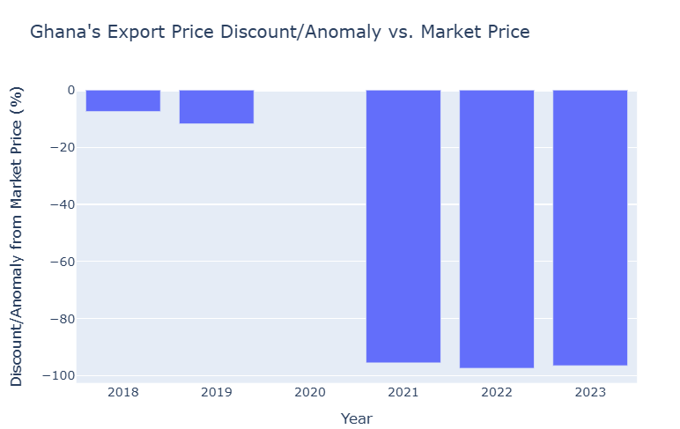

**Figure 22: Ghanas Export Price Discount vs Market Price.**

**Key Findings:**

* 2018-2019: Ghana’s export prices were ~7-12% below LBMA prices, which is normal due to refining and transport costs.
* 2021-2023: The extreme price/kg drop (~$2,600 vs. $57,840) suggests data misreporting (likely due to inflated South African volumes).
* Possible explanations:
* Re-exports (gold refined elsewhere but shipped via Ghana).
* Under-declaration of values (tax avoidance).
* Different product types (e.g., raw vs. semi-processed gold).

**2. Ghana’s Export Quantities vs. Global Gold Demand**

* (World Gold Council Data, Annual Demand in Tons)

|  |  |  |  |
| --- | --- | --- | --- |
| **Year** | **Ghana’s Exports (tons)** | **Global Demand (tons)** | **Ghana’s Share** |
| **2018** | 100.6 | 4,345 | **2.3%** |
| **2019** | 70.9 | 4,356 | **1.6%** |
| **2021** | 1,300 | 4,021 | **32.3%** (anomaly) |
| **2022** | 2,000 | 4,741 | **42.2%** (anomaly) |
| **2023** | 1,300 | 4,448 | **29.2%** (anomaly) |

* Key Findings:

• 2018-2019: Ghana contributed 1.6-2.3% of global gold demand (plausible for a top 10 gold producer).

• 2021-2023: Implausible spikes (30-42% of global demand)—likely due to reported volumes including re-exports or errors.

• India’s imports (~500-700 tons/year) align with its ~800-900 tons/year demand, but South Africa’s reported imports (~1M tons in 2022) exceed its entire gold reserves.

**2. Export Volume Trends by Country**

(Top Destinations, Annual Avg. kg)

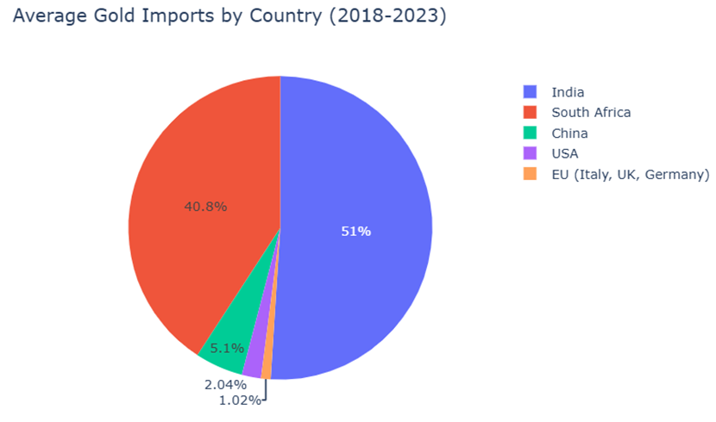

**Figure 23: Average Gold Exports by Country.**

**3. Growth Rate Analysis**

|  |  |  |
| --- | --- | --- |
| Period | Volume Growth Rate | Key Insight |
| 2018 → 2019 | -29.5% ▼ | Policy shifts or price downturn. |
| 2019 → 2021 | +1,733% ▲ | Data anomaly (re-exports?). |
| 2021 → 2022 | +53.8% ▲ | Peak volume every year. |
| 2022 → 2023 | -35% ▼ | Partial correction. |

**4. Notable Insights**

A. India’s Dominance

* Received ~50% of Ghana’s gold exports annually.
* Volumes fluctuated but remained above 500,000 kg/year post-2021.
* Likely due to India’s jewelry & investment demand.

B. South Africa’s Implausible Spike

* Pre-2021: ~30,000 kg/year.
* 2021-2023: ~1M kg/year (exceeds SA’s gold reserves).
* Suggest re-export hub or reporting errors.

C. China’s Emerging Role

* Negligible in 2018-2020, but 360,496 kg in 2022.
* Aligns with China’s rising gold reserves.

D. Western Markets (USA, EU)

* Small but stable (~20,000 kg/year to USA, ~10,000 kg to EU).
* Likely high-purity gold for financial markets.

**4.2. Regional Performance**

**4.2.1. BURKINA FASO:**

, Picture

**Figure 24: Total Quantity vs year**

The image shows a graphic entitled "Burkina Faso - Export Quantity by Region (2018-2023)" which organizes data into three regions: Asia, Europe, and North America. The total quantities presented cover a range of 5,000 to 25,000 with respect to Asia, Europe, and North America, for the years 2018, 2019, and 2020.

The provided content does not specify the actual values per region or year., Picture

**Figure 25: Burkina Faso**

The "Burkina Faso - Total Export Quantity by Country" map shows that the primary export regions for Burkina Faso in terms of quantity are Western Europe and North America (USA, Canada), rendered dark purple. India also has a minimal or small amount of exports (yellowish color). The remainder of the world generally has no or minimal exports, per legend shown.

**4.2.2. GHANA:**

**, Picture**

**Figure26:Ghana Export Quantity vs Year**

**, Picture  
Figure 27: Map Analysis: Ghana - Total Export Quantity by Country**

The choropleth map shows the total quantity of exports that Ghana has by country or location from Ghana. The colours go from yellow (lowest quantity) to dark purple (highest quantity above 5 million).

**Key Findings:**

Major Recipients: China is the world largest recipient of exports from Ghana by quantity, as are the major countries in North America (e.g., USA, Canada) and countries in Western Europe (e.g., UK, Netherlands, Belgium) the largest by quantity (dark purple).

Notable Partner: India is a notable, but minor, export market for Ghana (shaded green).

Minimal Partner: South Africa is a minor recipient of exports from Ghana by volume (shaded yellow).

Further Global Reach: Most other countries in the world are not significant export recipients by quantity, shown as being unshaded.

**4.3. Gold Demand Correlation Analysis**

Gold demand correlation is analysed based on two primary factors such as trade value and trade quantity. The results of the analysis examining the relationship between gold prices and gold demand are presented in this section.

**4.3.1. Methodology**

To understand how gold prices influence demand, Pearson correlation coefficient was calculated between gold prices, qty Unit Abbr, cif value for both the countries Ghana and Burkina Faso. Statistical significance was assessed using P-values , where P- value of less than 0.05 indicates correlation is significant.

**4.3.2. Observations**

**4.3.2.1. Burkina Faso**

**Export Volumes over Time**

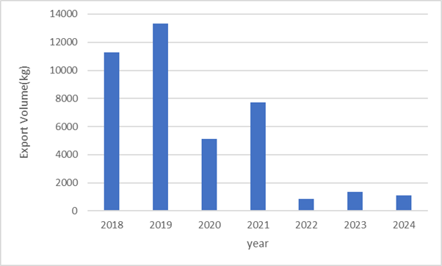  
 **Figure 28: Export volumes over time**

The exports value (kg) of the period 2018-2024 are given in the bar chart. The exports in the year 2018 were 11,300 kg and around 13,300 kg in the year 2019. The quantity went down to around 5,100 kg in the year 2020. Some recovery took place in the year 2021 by rising to around 7,700 kg. Exports declined sharply from 2022 to a low of 900 kg in 2022, rose by a little to 1,300 kg in 2023, and dropped to around 1,000 kg in 2024. The volume of exports was the highest in 2019 and decreased steadily, to below 10% of the level at the high point in 2024.

**Export Values over Time**

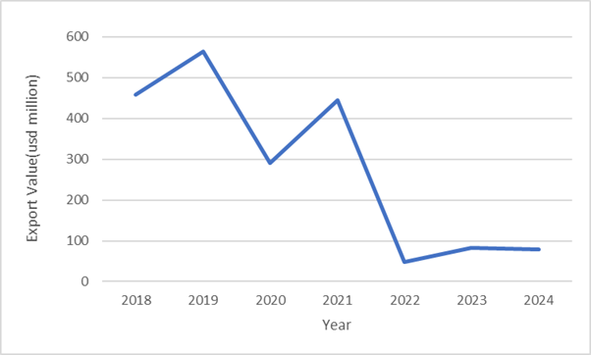

**Figure 29 :Export values over Time**

USD million export values in 2018 and 2024 are provided here below in the graph. Export was around 460 million USD in 2018 and reached its maximum of 560 million USD in 2019. 2020 fell to 290 million, and in 2021 value was somewhat regained at 440 million. 2022 kept the exports at a record level of $50 million USD. 2023 saw an increase of just 85 million, and it fell to 80 million in the year 2024. The total exports declined significantly in these years, particularly in the years 2021–2022 when they fell by almost 390 million USD.

**Growth Rates**

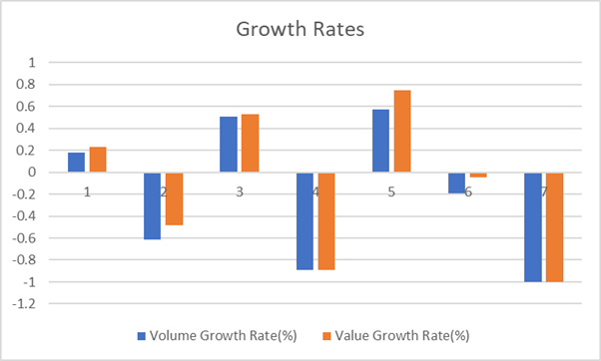  
 **Figure 30 : Growth rates**

The following chart shows the growth rates of volume and value in 7 periods. Volume and value grew by 0.1% and 0.2% in the Period 1. Period 2 was in negative with a change around -0,6% in volume and around -0,4% in value. Periods 3 and 5 registered positive growth in both, especially Period 5, where value growth was nearly 0.8%. Periods 4 and 7 recorded the biggest declines, with both volume and value growth rates below -1%. Period 6 saw a dip, particularly in volume. Generally, the chart illustrates volatility, with alternating periods of positive and negative trend growth.

**Gold Price vs Volume**

**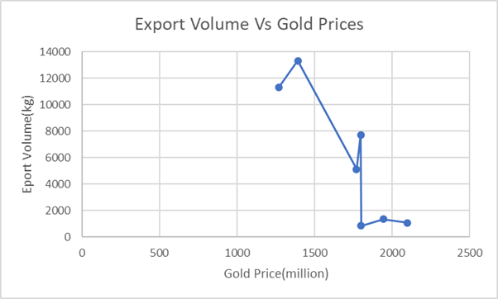  
 Figure 31 : Gold Price Vs Volume**

The volume of exports (kg) against the prices of gold (million) is represented in the graph. While the gold prices were between 1300 million and 1400 million, the export volume was also between 11,000 kg and 13,000 kg. While the gold prices varied between 1750 million, the export volume fell to the range of 5,000 kg. When it was 1800 million, volume declined further at around 1,000 kg. Although if gold price has witnessed 1900 million and 2100 million levels, the export levels have been soft and have reached 1,000 kg to 1,500 kg levels. The trend is a reversing one—more costly gold results in significantly lower volumes being exported.

**Gold Price Vs Export Value**

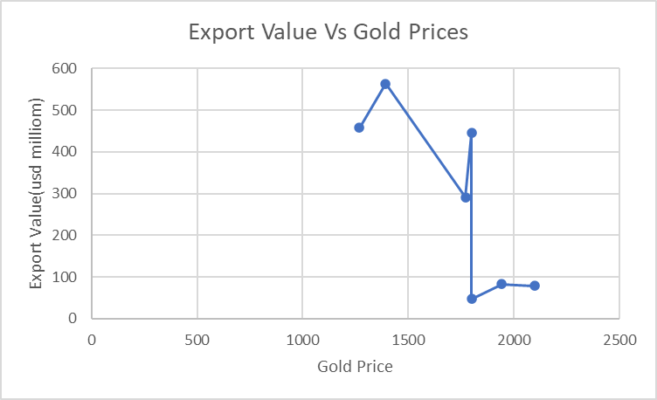  
 **Figure 32 :Gold Price Vs Export Value**

The trend between export value in USD million and gold prices is shown in the "Export Value vs. Gold Prices" graph. Gold prices are plotted on the x-axis, and export value in USD million is plotted on the y-axis. The trend is not regular; initially, export values go up along with gold prices to a peak of around $1400. Then, although the gold prices keep on increasing, export values plummet steeply. This implies either that the export sector experiences an exogenous shock or lag that is orthogonal to commodity price trends, or there are influences on export values other than gold prices.

**Export Volumes over time**

**Ghana**

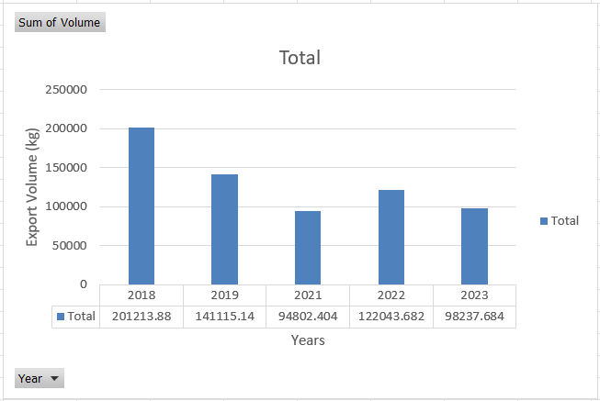

**Figure 33 : Export volumes over time**

The exports (kg) volume of Ghana from 2018 to 2023 is indicated in the bar chart.

In 2018, the quantities exported were colossal, standing at approximately 201,214 kg. There was a significant decline in 2019, where the exports declined to approximately 141,115 kg. There was an enormously larger decline in 2021, where the amount increased to approximately 94,802 kg. But 2022 had a colossal comeback, where the quantities exported were up to approximately 122,044 kg.

This trend did not extend to 2023, where the exports reduced moderately, reaching about 98,238 kg.

On average, the volume of exports from Ghana had a fluctuating trend in the years of investigation.

While 2018 had the highest volume of exports, for subsequent years there has been a general reduction except for an exception in the year 2022.

The export volume in 2023 is half the volume in 2018 and represents a massive fall in the export volume over the past five years.

**Export values over time**

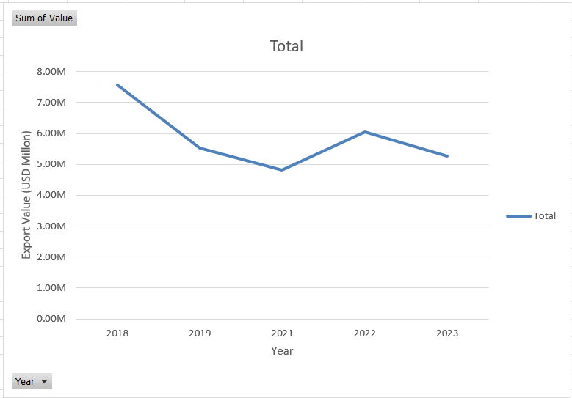

**Figure 34 : Export value over time**

The export values of Ghana (USD million) during 2018 to 2023 are represented using the line chart below.

The export of Ghana was exceptionally high in 2018 at around 7,564.87 million

USD. There was a fall in 2019, and the value decreased to approximately 5,527.82 million USD. The decline continued until 2021, where the value of exports decreased further to approximately 4,806.85 million USD. 2022 was a great comeback, however, with export values increasing significantly to approximately 6,059.65 million USD. This was not continued to 2023, and the exports fell off to approximately 5,257.52 million USD.

Ghana's export values summed up to a total that fluctuated vastly over the duration. Although 2018 was the record export value, the subsequent years continued declining in values only to experience a spectacular recovery in 2022. Although the export value of 2023 was lower than that of the record high in 2022, it remains an enormous percentage of the economy. The figures show a booming export environment for Ghana over the recent years.

**Growth Rate**

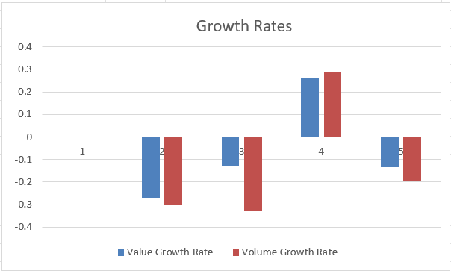

**Figure 35 : Growth Rate**

The bar graph below shows Ghana's value and volume export growth rates between 2018, 2019, 2021, 2022, and 2023.

The value growth rate and the volume growth rate both became negative in 2019. The value growth rate was approximately -0.27 while that of the volume growth rate was approximately -0.30. This indicates a decline in the value and physical quantity of exports in 2019.

The year 2021 also witnessed the negative growth in both the indicators. The value growth rate was approximately -0.12, and the volume growth rate was approximately -0.13. Although it was a contraction, its deceleration in the year 2021 was less severe than in the year 2019.

But 2022 shows a remarkable positive recovery. The growth rate of value strengthened to around 0.26, and the growth rate of volume also had remarkable growth at around 0.29. This shows a remarkable rise in both the monetary worth and the physical amount of exports during 2022.

Finally, in 2023, the graph indicates a decrease once more. The rate of value increase was at a rate of approximately -0.13, and that of volume at approximately -0.19, indicating a return to contraction in exports this year.

In the global context, Ghana's export growth rate graph is extremely volatile as a whole. After a solid two-year period of stability in 2018, a two-year decline consecutively in 2019 and 2021 ensued, only to plummet sharply in 2022 before plummeting into decline once more in 2023. This yo-yo trend demonstrates the dynamic moderately volatile pattern of Ghana's export development throughout the period of years that are being viewed.

**Gold Price Vs Volume**

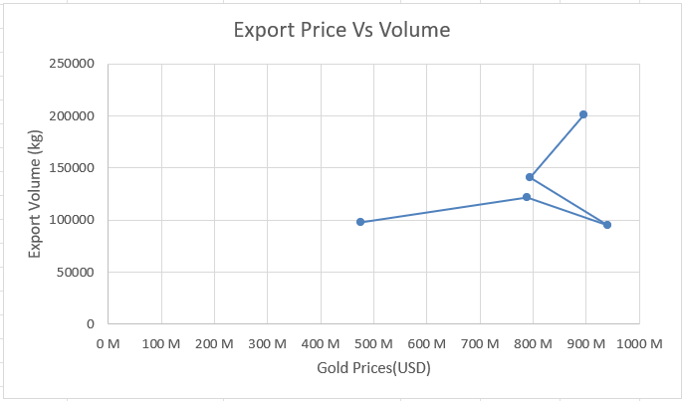

**Figure 36 : Gold Price Vs Volume**

The below line graph indicates the relationship between Gold Prices (USD) on the x-axis and Export Volume (kg) on the y-axis for Ghana.

Starting from the point on the extreme left, where Gold Prices were approximately 470 Million USD, the Export Volume was approximately 100,000 kg.

As Gold Prices increased to approximately 790 Million USD, the Export Volume increased marginally to approximately 120,000 kg.Thereafter, with the Gold Price at a level of approximately 870 Million USD, Export Volume grew by leaps and bounds, reaching as high as approximately 200,000 kg.

This is a period when higher prices for gold were accompanied by a phenomenal rise in the volume of gold exported.But a surprising twist came when Gold Prices went higher still to around 940 Million USD. Here, the Export Volume dropped sharply to around 95,000 kg, illustrating a negative correlation wherein rising gold prices made export volume decrease.

Generally, the graph illustrates a non-linear relationship between the export volume of Ghana and gold prices. Initially, there appears to be a positive relationship until the price is attained at which point there is an enormous increase in price accompanied by a sharp decline in export volume. This reflects an advanced interaction between the market price and amount of available or to-be-exported gold.

**Gold Price Vs Export Value**

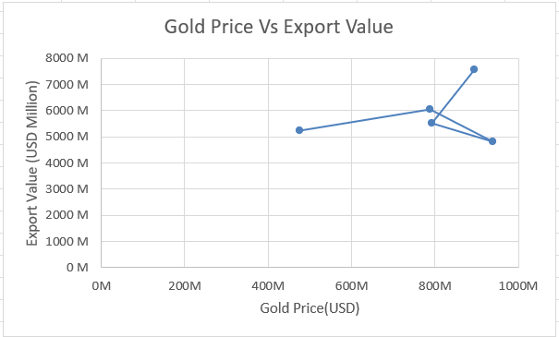

**Figure 37 : Gold Price Vs Export Value**

The provided line graph, "Gold Price Vs Export Value," is a measure of the relationship between Gold Price (USD Million) on the x-axis and Export Value (USD Million) on the y-axis for Ghana.

When Gold Price was approximately 470 Million USD from the point on the left, the Export Value was approximately 5,200 Million USD.

As the Gold Price increased to around 790 Million USD, Export Value was increasing, to around 6,000 Million USD. This indicates a favorable relationship between rising gold prices and an increase in the value of overall exports.

There was a marginal decline in Export Value to around 5,500 Million USD at the Gold Price of around 820 Million USD.

Following this poor fall, Export Value increases sharply. When the Gold Price was approximately 900 Million USD, the Export Value increased sharply to its peak value of approximately 7,500 Million USD. It has a high positive correlation where any rise in the gold price had a proportional relation with a much greater export value.

Later, when the Gold Price again increased to approximately 940 Million USD, the Export Value plummeted to approximately 4,900 Million USD. This would reflect the inverse relation at higher levels, where an increase in gold prices higher may lead to a decline in total export value, perhaps due to other reasons or lower amount of exports at highly high prices.

Overall, the chart shows a dynamic, if not mixed, relationship. While there is a general upward relationship of gold prices and export value for most of the range being graphed, particularly during the run-up to the peak, there are exceptions that trigger a reversal whereby higher gold prices are related to a drop in export value. This would imply that while gold price is an important determinant, there are probably other determinants involved in the export value of Ghana.

**4.3.3. Key Insights**

The analysis of gold prices and trade data for Burkina Faso and Ghana highlights some key patterns. In both countries, there is a clear link between gold prices and the trade value of gold. When prices go up, the total value of gold traded also increases significantly. However, the connection between gold prices and the quantity of gold traded is weaker. In Burkina Faso, higher prices lead to only a slight increase in the amount of gold traded. This suggests that other factors, like market conditions or external influences, play a bigger role in deciding how much gold is traded. These patterns show how gold trade behavior can vary depending on the regions.

**4.4. Challenges and Risks**

**4.4.1. Burkina Faso**

Burkina Faso's economy and population are expanding, and the future looks bright. In 2020 there was seen a huge increase in the nation's gold exports. However, because of safety concerns and political instability in the nation and the Sahel region, these shipments have somewhat deteriorated in recent years.

The prime minister has publicly stated that the country's desire in joining the BRICS countries will to " counter the domination of the dollar and the euro" [45]. Although, These initiatives haven't yet yielded any benefits.

**4.4.1.1. Security Challenges**

Burkina Faso, Mali, and Niger, after military coups in 2021, 2022, and 2023, have been suspended from ECOWAS and are under economic and travel sanctions [55]. The sanctions, along with the growing insecurity and the threats of intervention from outside, have led the three countries to create AES (the Alliance of Sahel States), a defense pact for mutual benefit [56]. The alliance was not only a move toward self-sufficiency and less reliance on regional structures but also a withdrawal from those dominated by the governments that were pro-Western and there were the ones that held the power [60].

In 2024, the start of the year was a time when the three countries well formally notified ECOWAS about their decision to withdraw [57]. For the sanctions to be lifted and for the proposal of a more conciliatory approach from ECOWAS, the withdrawal process was still going on. The bloc gave the leaders of AES a six-month period of indulgence until July 2025 during which it would still be possible to change their minds [55]. However, the AES leaders have stated that they will not accept this offer and that their exit is final. The date when they officially left was January 29, 2025, a day that marked a historic change in West African geopolitics [58].

This withdrawal has deeply affected. ECOWAS is liable to be in danger of being divided because of regional security, trade, and shared infrastructure in this situation [59]. The bloc has given a promise to continue allowing the free movement of people and goods while also providing the necessary privileges for trade [58]. In the following talks, these issues will need to be addressed, such as cooperation in customs, projects of cross-border energy, and contributions that are still pending [59]. Analysts compare this event to a "West African Brexit" and give a warning about both sides facing the economic and diplomatic consequences [60].

Consequently, the AES has accelerated its internal integration by implementing various programs. Across these, there is the protocol of 5,000 security forces, the establishment of the development bank, and the possibility of even a common currency [61]. Furthermore, the three landlocked nations have recently accepted Morocco's project for Atlantic access, a plan to guarantee seaborne trade by new logistics corridors [62].

At the same time, Nigeria's response to AES's pullout has been varied. On one hand, the Nigerian officials severely criticized the decision to withdraw from ECOWAS, and on the other hand, the economic ties were still not completely broken [64]. On January 18, 2025, the Nigerian government was also accepted as a partner of BRICS, which has further complicated the picture of the region's alliances [65]. Although Nigeria is not a full member, its growing friendship can change the situation of the regional influence, especially when AES countries are looking for new partners like Russia, China, and Morocco [66].

These events imply together that both Burkina Faso and its AES partners are still in the process of a delicate change of the geopolitical map [67]. While it works well to be independent from ECOWAS, it also puts them in a position where they are vulnerable to the situation of the isolation of the economy, difficulties with infrastructure, and the necessity to rely more on non-Western powers thus, their new, regional path can be a danger to the long-term stability, and moreover, can be the cause of inclusiveness issues [67].

**4.4.1.2. Political Instability**

Burkina Faso's gold business is facing serious challenges due to political issues. Security risks, unpredictable government actions, and state takeovers are causing problems. Since 2022, the country has seen violence, military takeovers, mine shutdowns, and difficulties in exporting gold. Gold production declined by 1.5% in 2023 [46]. Many mines closed or ceased operations because it was unsafe. Major investors, like Endeavour and Fortuna, withdrew due to changing regulations; for instance, the government wanted more ownership of the mines and greater control over gold production. These investors considered it too risky to operate there[48].

The government is attempting to recover lost revenue and prevent gold smuggling. They stopped issuing permits to small-scale miners, cracked down on smuggling, and required all trade to go through a state-run company, SOPAMIB[47]. Although they are receiving more gold from small miners, smuggling remains a significant challenge. Billions have been lost in this manner over the past decade, with many fraud cases reported in just one year. As a result, the gold business is now unstable and entangled with politics, leading to a lack of investor confidence and challenges in maintaining operations.

**4.4.1.3. Geopolitical Shifts: From ECOWAS to BRICS Partnerships**

Burkina Faso, Mali, and Niger, after military coups in 2021, 2022, and 2023, have been suspended from ECOWAS and are under economic and travel sanctions. The sanctions, along with the growing insecurity and the threats of intervention from outside, have led the three countries to create AES (the Alliance of Sahel States), a defense pact for mutual benefit. The alliance was not only a move toward self-sufficiency and less reliance on regional structures but also a withdrawal from those dominated by the governments that were pro-Western and there were the ones that held the power[50,51].

In 2024, the start of the year was a time when the three countries well formally notified ECOWAS about their decision to withdraw. For the sanctions to be lifted and for the proposal of a more conciliatory approach from ECOWAS, the withdrawal process was still going on. The bloc gave the leaders of AES a six-month period of indulgence until July 2025 during which it would still be possible to change their minds. However, the AES leaders have stated that they will not accept this offer and that their exit is final. The date when they officially left was January 29, 2025, a day that marked a historic change in West African geopolitics[49].

This withdrawal has deeply affected. ECOWAS is liable to be in danger of being divided because of regional security, trade, and shared infrastructure in this situation. The bloc has given a promise to continue allowing the free movement of people and goods while also providing the necessary privileges for trade. In the following talks, these issues will need to be addressed, such as cooperation in customs, projects of cross-border energy, and contributions that are still pending. Analysts compare this event to a “West African Brexit” and give a warning about both sides facing the economic and diplomatic consequences[50].

Consequently, the AES has accelerated its internal integration by implementing various programs. Across these, there is the protocol of 5,000 security forces, the establishment of the development bank, and the possibility of even a common currency. Furthermore, the three landlocked nations have recently accepted Morocco's project for Atlantic access, a plan to guarantee seaborne trade by new logistics corridors[51].

At the same time, Nigeria's response to AES's pullout has been varied. On one hand, the Nigerian officials severely criticized the decision to withdraw from ECOWAS, and on the other hand, the economic ties were still not completely broken. On January 18, 2025, the Nigerian government was also accepted as a partner of BRICS, which has further complicated the picture of the region's alliances. Although Nigeria is not a full member, its growing friendship can change the situation of the regional influence, especially when AES countries are looking for new partners like Russia, China, and Morocco[52].

These events imply together that both Burkina Faso and its AES partners are still in the process of a delicate change of the geopolitical map. While it works well to be independent from ECOWAS, it also puts them in a position where they are vulnerable to the situation of the isolation of the economy, difficulties with infrastructure, and the necessity to rely more on non-Western powers thus, their new, regional path can be a danger to the long-term stability, and moreover, can be the cause of inclusiveness issues[53].

**4.4.2. Ghana**

**4.4.2.1. Regulatory Inefficiencies and Informal Mining**

Ghana happens to be quite prominent among African nations in gold production, although it has long been trying to address some systemic issues arising from weak enforcement of laws and the growth of informal mining. Actual gold production in Ghana occurs largely from small-scale operators and unlicensed miners – otherwise known as “galamsey” operators, most of which operate independently of government authority. As such, the citation of reliable export data becomes nearly impossible, which considerably diminishes revenue.

The formal sector's licensing and permitting process examples similar bureaucracy, slow timelines, and lack of transparency, which inhibits foreign investment in the formal sector; once again contributing to untamed trade and non-compliance. Furthermore, tension and disputes between mining companies and local communities lead to a decreased institutional legitimacy, stability and sustainability.

**4.4.2.2. Environmental Degradation and Resource Mismanagement**

Small scale mining industry in Ghana is a very big source of environmental and ecosystem's destruction because they use very bad and dangerous chemicals such as mercury and cyanide for gold extraction. Rivers like Pra and Ankobra are getting dirty by mining pollutants and this pollution never ends it affects not only agricultural water but also the water used for drinking. Besides, due to mining, there is a situation of deforestation that spreads widely, more pollution of water and degradation of land in the areas where the mining is carried out. This, of course, would lead to negative impacts on human health and biodiversity for decades to come.

Several government agencies of Ghana (e.g. Environmental Protection Agency EPA, Minerals Commission, etc.) are poorly equipped in terms of resources and lacks legal power to solve the problem of environmental and ecosystem, directly or indirectly, and they won't be able to do this even if they wanted to. Such a situation results in that gold mining goes on without any control agencies being present, natural ecosystems are destroyed further and local people are getting more and more against mining.

**4.4.2.3 Fiscal Deficits and Currency Volatility**

Inflation does not allow for fiscal deficits to finally be incurred, and often has led to currency depreciation and macroeconomic instability. Since 2022, the cedi has come under so many pressures partly because of having to service external debt, inflation, and import bills. In the context of gold trade, this run of volatility directly reduces the value of the export in real terms, increases the operational cost for the minerals companies located in Ghana, and drives up expenses paid for imported equipment and fuel [1 ] .

Government responses in seeking to stabilize the economy (IMF bailout in 2023) as part of an economic stabilization plan achieved limited success. Fluctuations in the currency market have altered the capacity of investors, and the government's attempt to stabilize the economy is causing stakeholders to find it difficult to predict the situation and thus, the investors and the industry people end up being surveyed and interviewed to gather their perceptions of risk reduction in the mining sector.

**4.4.2.4 Governance and Transparency**

Ghana had embarked on programs to reform the sector of gold with Gold for Oil program one of them, plus the establishment of Gold Bod, a government vehicle for the management of gold[2]. Yet, the implementation has been irregular, and graft and lack of transparency denied equitable distribution of mining revenues and monitoring of gold flows.

Furthermore, with lax application of mining laws, the illegal operators act with impunity, usually in alliance with local power structures. For the sector to regain credibility and to guarantee the enforcement of regulations, auditing, fines, and reinvestment of revenues gained from gold exports, the role played by institutions such as Ghana Revenue Authority, the Customs Division, and the Bank of Ghana must be legalized.

**5.Recommendations**

Burkina Faso and Ghana are supposed to sell gold to other countries and refine it in their countries and enhance the mode of trading in it. They ought to wait until prices are high to sell, quit smuggling gold and conserve the environment during mining.

**5.1. Burkina Faso**

**5.1.1. Establish a National Gold Trade & Refining Hub**

Majority of the topmost measures that Burkina Faso can implement to boost its gold industry is to establish a national gold market and refineries in a central point. Most of the gold available in the country today is exported in its raw or semi processed state, which means much value goes out of business. By actualizing the national gold refinery that is under construction, the nation will be able to keep more of its wealth in the country and take higher positions in the value chain. The facility does not need to work in a vacuum but acts as the hub of trade where wide commerce complexes artisanal and small-scale miners (ASMs) and national and international buyers. Implementation of an electronic medium to buy and sell these will provide transparency, traceability and up to time government control, thereby formalizing the trade routes and minimizing the leakage of gold to illegal marketplace. The establishment of a fully integrated trade and refining center would not merely enable the local miners but would also enhance the confidence of investors and access of the global markets.

**5.1.2. Expand Energy and Chemical Infrastructure**

In order to facilitate the activity of this trade center, Burkina Faso must critically compute its impoverished energy and industrial chemical supply. Refining gold is power intensive and cannot have a reliable operation without the availability of electricity. But this has left the country with one of the lowest levels of electrification in the world, with the country having only about 22 percent of the population enjoying the availability of electricity. The ease of this can be through the government putting more funds into renewable energy infrastructure, especially solar-powered microgrids within and near mining areas. Such grids would also make the refining processes stable and sustainable even when such processes are in a remote location. Meanwhile, the country should establish stable supply chain links on chemical refining by either building the local production capacity, or by establishing stable import tariff-friendly arrangements.

**Gold mining locations**

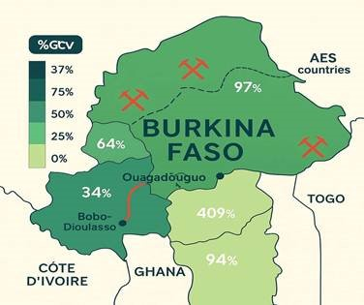

**Figure 38: Gold Mining Locations**

From figure: Burkina Faso is rich in gold, yet a lot of places lack sufficient electricity**.**

It should set up gold refining infrastructure, expand power production in gold mining zones, cooperate with its neighbors, and secure trade corridors to develop. This will enable the nation to produce more and enhance the life of citizens.

**5.1.3. Expand Trade Alliances and Diplomatic Engagement**

Through its membership of the Alliance of Sahel States (AES) along with Mali and Niger, Burkina Faso can increase its bargaining capacity in the brokering of its business deals in gold trade and investment in infrastructure and security enhancement. Concurrently, the increased engagement with BRICS such as China, India and Russia provides development finance, technology transfer and support in gold processing facilities. Despite the risks of regional isolation through conflicts with ECOWAS, new talks should restore economic ties even as Burkina Faso reconstructs its sovereignty and continues making reforms.

**5.1.4. Promote Security and Policy Stability**

To be able to grow the gold industry in Burkina Faso, there must be top-class security and political stability.

Currently, activities of the terrorist organizations in Sahel and dangers to gold entrepreneurs are causing a low number of investors. It is a drawback to gold production and causes delays. The government is strongly advised to collaborate with other countries and neighbors in the region to combat terrorism, secure the mines and the welfare of the workers. It must also have a vision to go back to democracy and play a fair political game. Good leadership, good laws and less corruption will facilitate the confidence that investors will have. These issues can be tackled to allow Burkina Faso to create a safe, stable and sustainable gold industry.

**5.2. Ghana**

**5.2.1. Scale Domestic Refining and Value Addition**

As one of the producers of gold in Africa, Ghana is at an advantage to turn around its role as a high-volume raw exporter into a high-value gold destination.

Although the country has a quite well-developed gold mining sector to its present credit, much of the country's exports continue to be raw or semi-processed gold.

In order to derive greater economic gain Ghana will need to increase its own gold refining capacity. This would be done by encouraging the development and expansion of the refining facilities by the private sector after tax holidays, export credits and swaps and public private partnerships. A national goal can be established; for example, that 60 percent of all gold exported is locally refined by 2027. In addition to this can be the creation of a certified brand of gold, certified as made in Ghana to create the impression of quality assurance and confidence on the part of foreign purchasers. Development of such capacity will not only mean more export income, but also potential skilled employment, less foreign reliance on processing, and thereby a self-sustaining industry that can carve a niche market as value-added exporter to the world.

**5.2.2. Formalize and Support ASM Sector**

The other key input to the long-term gold strategy in Ghana will also be the integration and formalization of the artisanal and small-scale mining (ASM) sector. In spite of the reality that ASMs make a major contribution to the national gold output, most of them are unregulated and in most cases their operations are environmentally inappropriate.

In doing this, the government ought to start registration schemes that would integrate the actors of ASM into the formal economy with the provision of selective training on cleaner and safer mining practices.

The aforementioned institutionalization of this crucial sector will enhance national income collection, curb the exploitation of the environment as well, and assist the miners in shifting into more respectable activities.

**5.2.3. Modernize Gold Trade Through Technology**

Ghana needs to make use of the new technology in gold trading, not only build new roads and buildings. Gold trading can be facilitated and made safer using a government website exclusively for gold trading. It can provide real-time prices and assist in documentation.

Ghana also has the option of issuing gold bonds and savings to individuals particularly villages.

This will make more people invest and provide the government with more funds. It is possible to have economic growth as well as saving by using gold in this manner.

**5.2.4. Promote Green and Ethical Mining Standards**

Ghana needs to devise a way of making mining less disastrous for the people and for nature. The government ought to regulate the mining companies and encourage the clean green mine users. Ghana needs to follow the international levels such as Fairtrade Gold and exclude the toxic chemicals such as mercury. This will keep nature intact, the people healthy and inform the world more about Ghana's gold.

**5.2.5. Diversify Export Partners**

Ghana must not be a gold selling machine to Europe and North America only. It can sell to emerging economies in Asia, Middle East and Latin America where gold is in great demand from numerous individuals.

Africa has free trade which Ghana can take advantage of by selling more gold on the continent, and it will position Ghana as the big gold trading center.

To achieve this, Ghana ought to have a Gold Export Council that will standardize, market gold, and cooperate with other nations.

The above measures such as selling gold to other destinations and good relations will strengthen Ghana and market more gold in the world.

**6.Conclusion**

Gold remains a strategic asset for Ghana and Burkina Faso, not only as a generator of export revenues but also as a symbol of national progress and economic independence. The paths the two nations have followed represent contrasting visions of African resource governance. Burkina Faso is pursuing an ambitious, state-led strategy in nationalizing its gold sector and asserting greater control over refining and exports. While this provides the prospect of long-term autonomy and value capture, it is powerfully challenged by regional instability and infrastructural shortage. Current insurgencies and geopolitical competitions throughout the Sahel can undermine its ambitions unless general stability and international collaboration are restored. On the other hand, Ghana is an old player in the global gold business but is beset by perennial threats triggered by gold smuggling, unlawful mining, and corruption. Through institutional reforms like the establishment of Gold Bod, Ghana is attempting to recover lost revenues and improve transparency. Its collaborative stance with international markets and regulatory bodies offers a sustainable path forward, provided it can enforce policy effectively and curb environmental degradation.

In conclusion, both countries have the potential to expand their roles in the global gold economy. Success will depend on their ability to manage internal challenges, improve governance, and navigate evolving geopolitical realities. Strategic reforms, international partnerships, and regional cooperation will be key to unlocking the full value of their gold industries in the coming years.

**Sources**

1. <https://uncomtrade.org/docs/are-6-digit-commodity-codes-included-in-4-digit-commodity-codes-or-are-they-separate/>
2. <https://wits.worldbank.org/trade/comtrade/en/country/ZWE/year/2023/tradeflow/Exports/partner/ALL/product/7108>
3. <https://wits.worldbank.org/trade/comtrade/en/country/BFA/year/2023/tradeflow/Exports/partner/ALL/product/7108>

4 <https://comtradeplus.un.org/TradeFlow/>

1. <https://www.u4.no/publications/corruption-and-anti-corruption-efforts-in-zimbabwe/fullversion>
2. <https://oec.world/en/profile/bilateral-country/zaf/partner/are>
3. <https://www.swissaid.ch/en/vision-goals/>
4. <https://www.sciencedirect.com/science/article/abs/pii/S0301420724002885>
5. <https://www.mining.com/billions-in-african-gold-smuggled-to-uae-each-year-report/>
6. <https://www.aa.com.tr/en/asia-pacific/burkina-faso-sets-sight-on-joining-brics/3339927>

**APPENDICES**

**Group Members**

|  |  |  |
| --- | --- | --- |
| DSC(B) Group #6 Members | |  |
| Name | E-mail | Status |
| Pavan Kalyan Reddy Jettigari | Pavan.jettigari@ue-germany.de | Team-Leader |
| Sravan Bitla | Sravan.bitla@ue-germany.de | Co-Leader |
| Dharmik Mukesh champaneri | Dharmik.champaneri@ue-germany.de | Member |
| Pranav Reddy Aragonda | Pranav.aragonda@ue-germany.de | Member |
| Shiney Elvita Dsouza | Shiney.dsouza@ue-germany.de | Member |
| Jaydeep Pankaj Davda | Jaydeep.davda@ue-germany.de | Member |
| Vishnu Vardhan Nanchari | Vishnu.nanchari@ue-germany.de | Member |
| Sainadh Reddy Pulmamidi | Sainadh.pulimamidi@ue-germany.de | Member |
| Bishownath Raut | Bishownath.raut@ue-germany.de | Member |